

|  |  |
| --- | --- |
| **Teacher Name : Sir Mohsin Ali** | **Course Title: Virtual Systems and Services Lab** |
| **Department: Information Technology** | **Program: BS-IT 7th Blue** |
| **Student Name: Insheerah Khan** | **Roll No: 24020103-005** |

**University of Sialkot, Pakistan**

**Lab Task #2**

**Task Title**

**Creating and Using Virtual Machines with Windows 8.1 and Ubuntu**  
  
**Step 1: Installing Virtualization Software and Setting Up Windows 8.1 VM**

* To begin, I downloaded and installed VMware Workstation on my computer. After launching the application, I clicked **on “Create a New Virtual Machine.”**

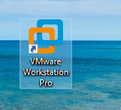

* The setup wizard appeared. I selected **“Typical (recommended)”** and clicked Next. Then, I chose **“Installer disc image file (ISO)”** and browsed to the location of the Windows 8 ISO file.
* Next, I named the virtual machine **“Windows 8 VM”** and selected a location to save the VM files.
* I allocated **60 GB** for the virtual hard disk and selected **“Store virtual disk as a single file.”** Before finalizing, I clicked **“Customize Hardware”** to set:
* RAM: 2 GB (recommended minimum)
* Processor cores: 1 or more

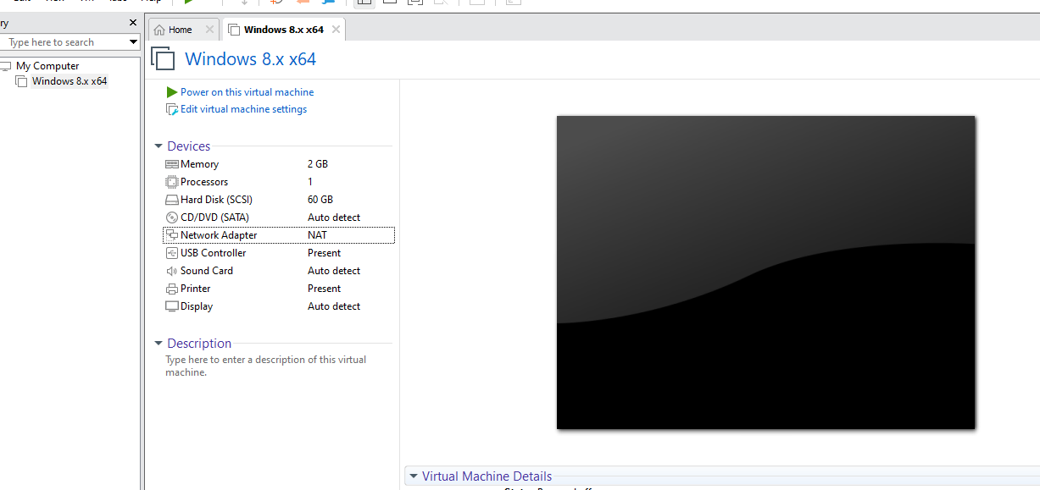

* After clicking Finish, the virtual machine started, and the Windows 8 installation began. I followed the on-screen instructions:
* 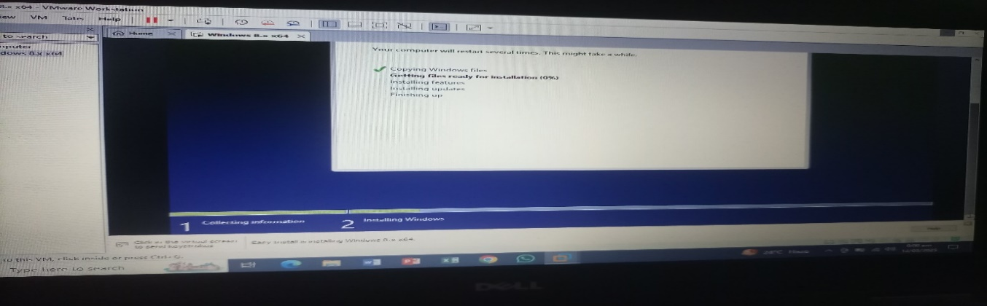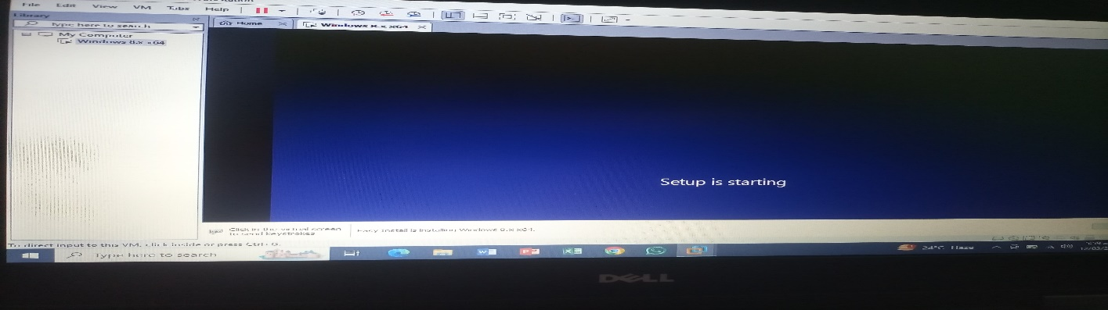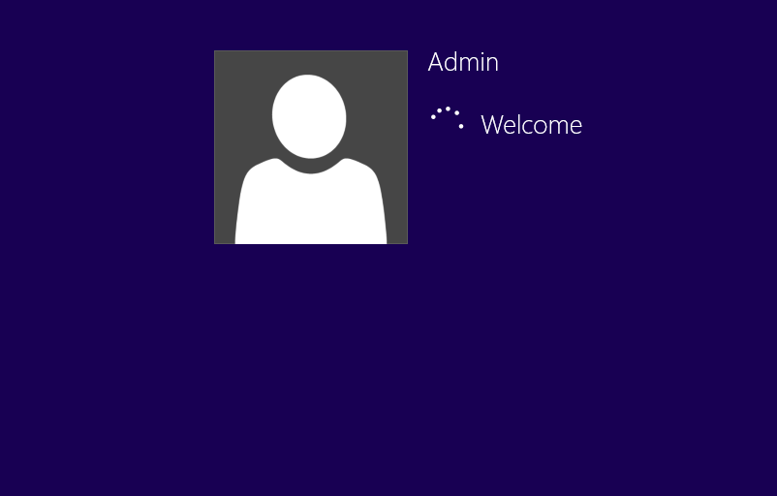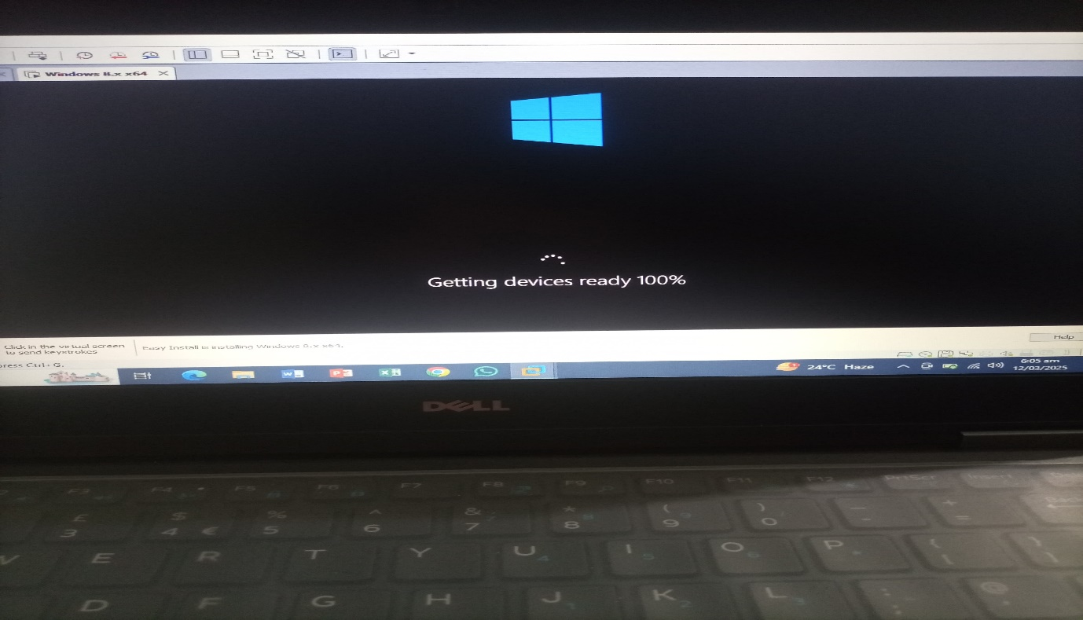 Chose language and region .Clicked Install Now. Chose Custom Installation. Selected the virtual disk to install Windows  
  Once installation completed and the VM restarted, I set up the user account and preferences. When the Windows 8 desktop appeared, installation was successfully done.

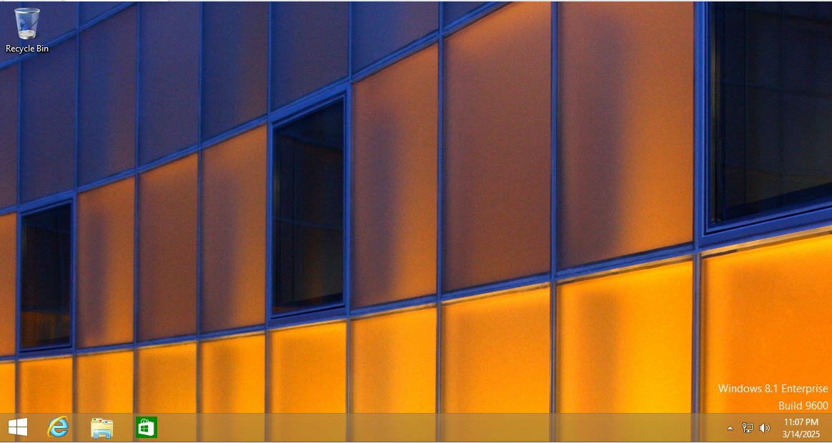

**Step 2: Downloading Ubuntu ISO File**

* For the next VM, I needed **Ubuntu**. So, I visited the official Ubuntu website and downloaded version **24.04.2.**
* 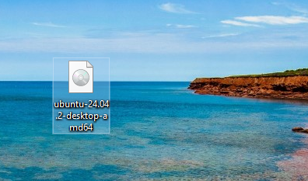After the download finished (around **4–5 GB**), I confirmed the file was complete and saved it in a known location. I also took a screenshot showing the file name and size.

**Step 3: Creating a New Virtual Machine for Ubuntu**

* To set up Ubuntu, I reopened VMware Workstation Player and selected **“Create a New Virtual Machine.”**

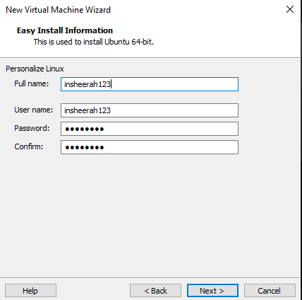

* I named the VM “Ubuntu”, selected Linux as the OS type, and Ubuntu (64-bit) as the version.  
  Then I configured:
* RAM: 4 GB
* CPU Cores: 2
* Disk Size: 20 GB  
  I also mounted the previously downloaded Ubuntu ISO file so the VM could boot from it.

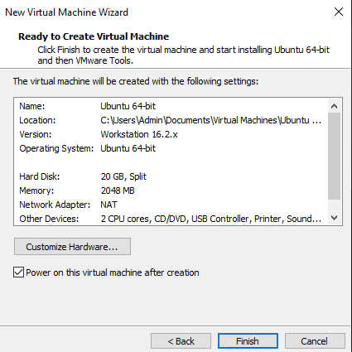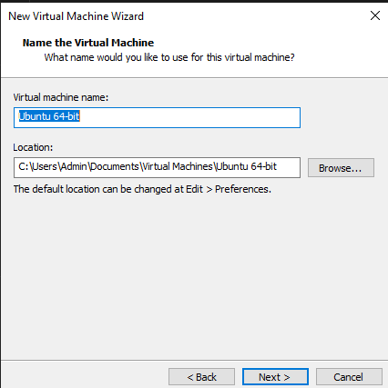

**Step 4: Installing Ubuntu on the VM**

* I started the Ubuntu VM, and the installer loaded successfully.
* I selected the appropriate language and keyboard layout, then clicked Install Ubuntu. I went with the default installation settings (erase disk and auto-partitioning). I created a user account with a username and password.
* 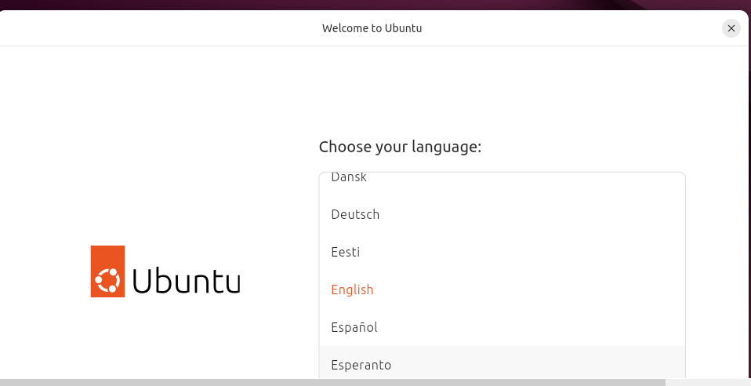After installation, the VM rebooted, and I was able to log in to the Ubuntu desktop.

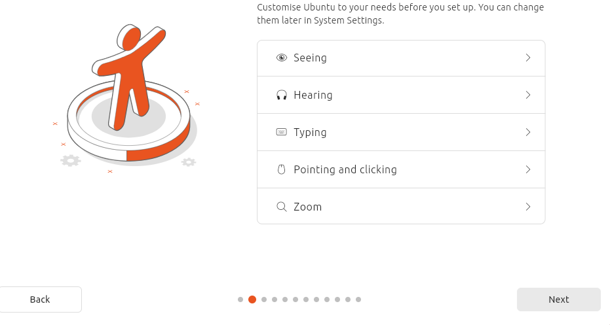

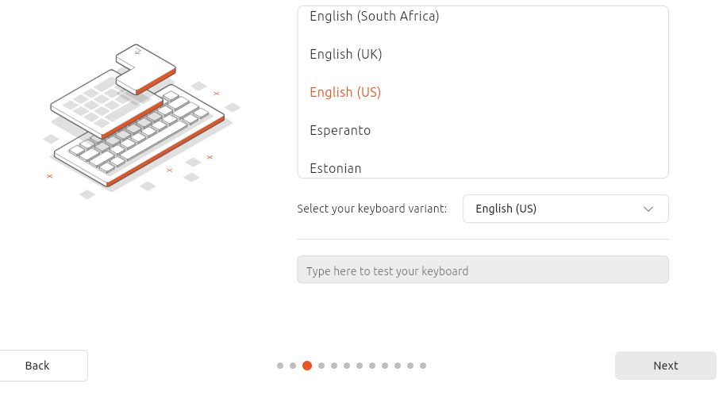

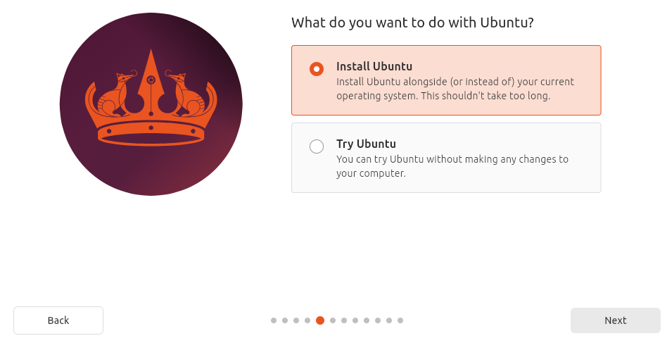

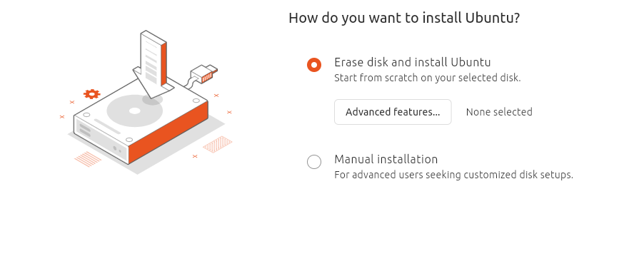

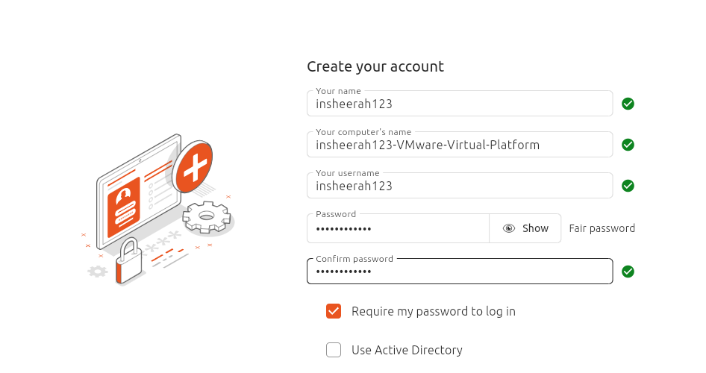**Step 5: Sharing Files and Setting Up Remote Access**  
  
**File Sharing:**  
To share files between the host and Windows 8 VM:

* With the VM powered off, I went to:  
   Player / VM > Settings > Options tab > Shared Folders

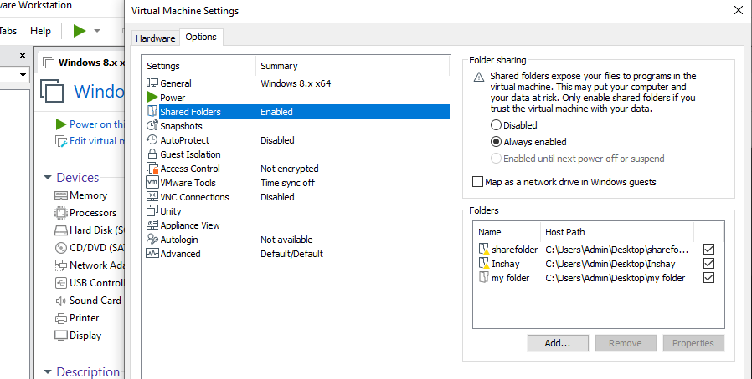

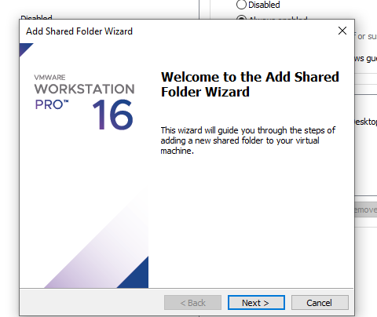

* I enabled shared folders and clicked “Add”. I chose a folder from my host PC (e.g., C:\Users\Admin\Desktop\my folder) and gave it a name like “**my folder”.**

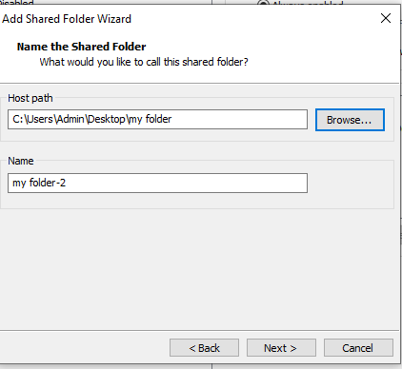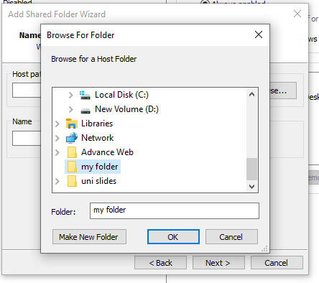

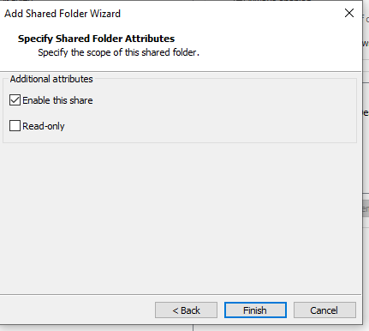

* Inside the Windows 8 VM:
* I went to This PC, and the shared folder appeared as a network drive. I could copy files from host to VM and from VM to host using this shared folder.

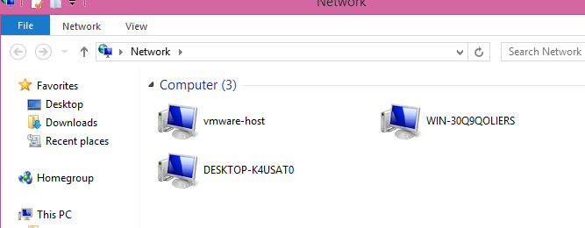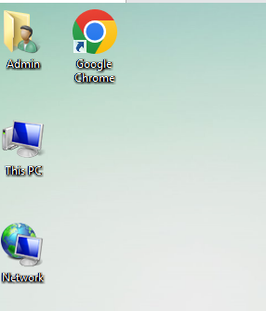

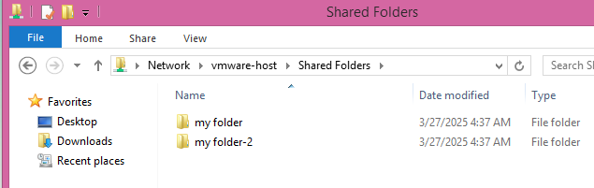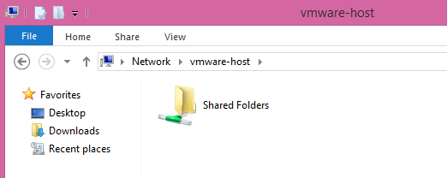

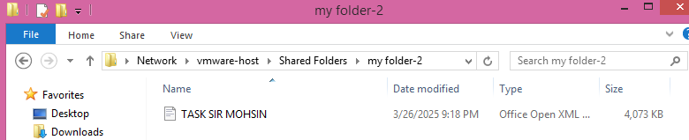

**Remote Access using RDP:**

To enable remote desktop:

* Inside the Windows 8 VM, I opened System Properties.
* Clicked Remote Settings.
* Enabled: Allow remote connections to this computer.
* I noted the VM’s IP address using the ipconfig command in Command Prompt (e.g., 192.168.60.129).

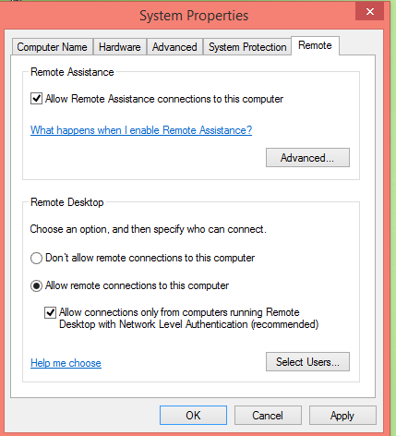

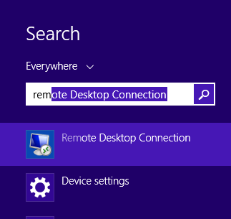

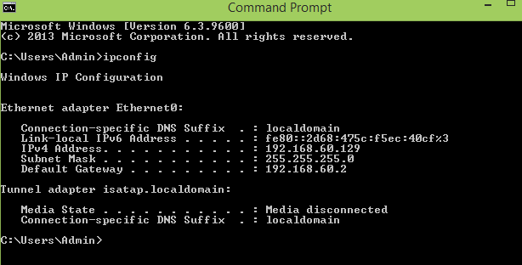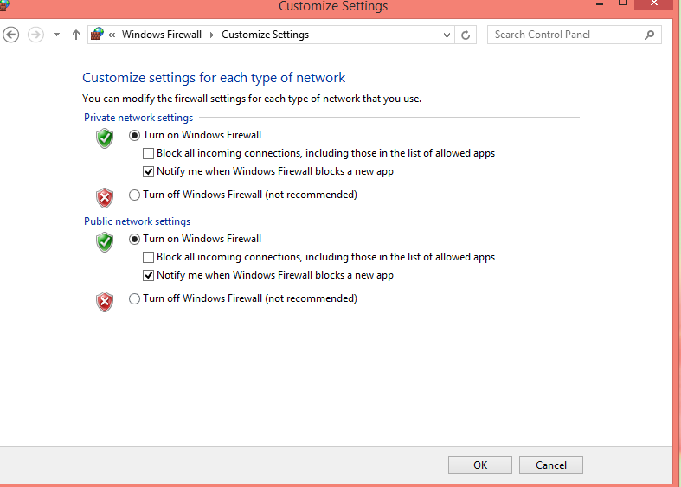

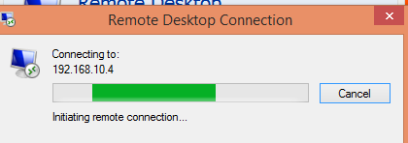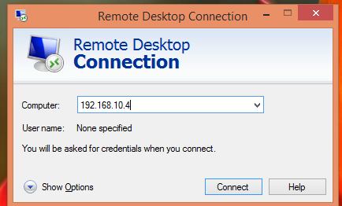

**To connect from the host PC:**

* Pressed Windows + R, typed mstsc, and pressed Enter.
* Entered the VM’s IP address and clicked Connect.
* Logged in using the VM’s username and password.

